St. John’s College’s Builders Club
Stronger Together- Supporting Our School Clinic

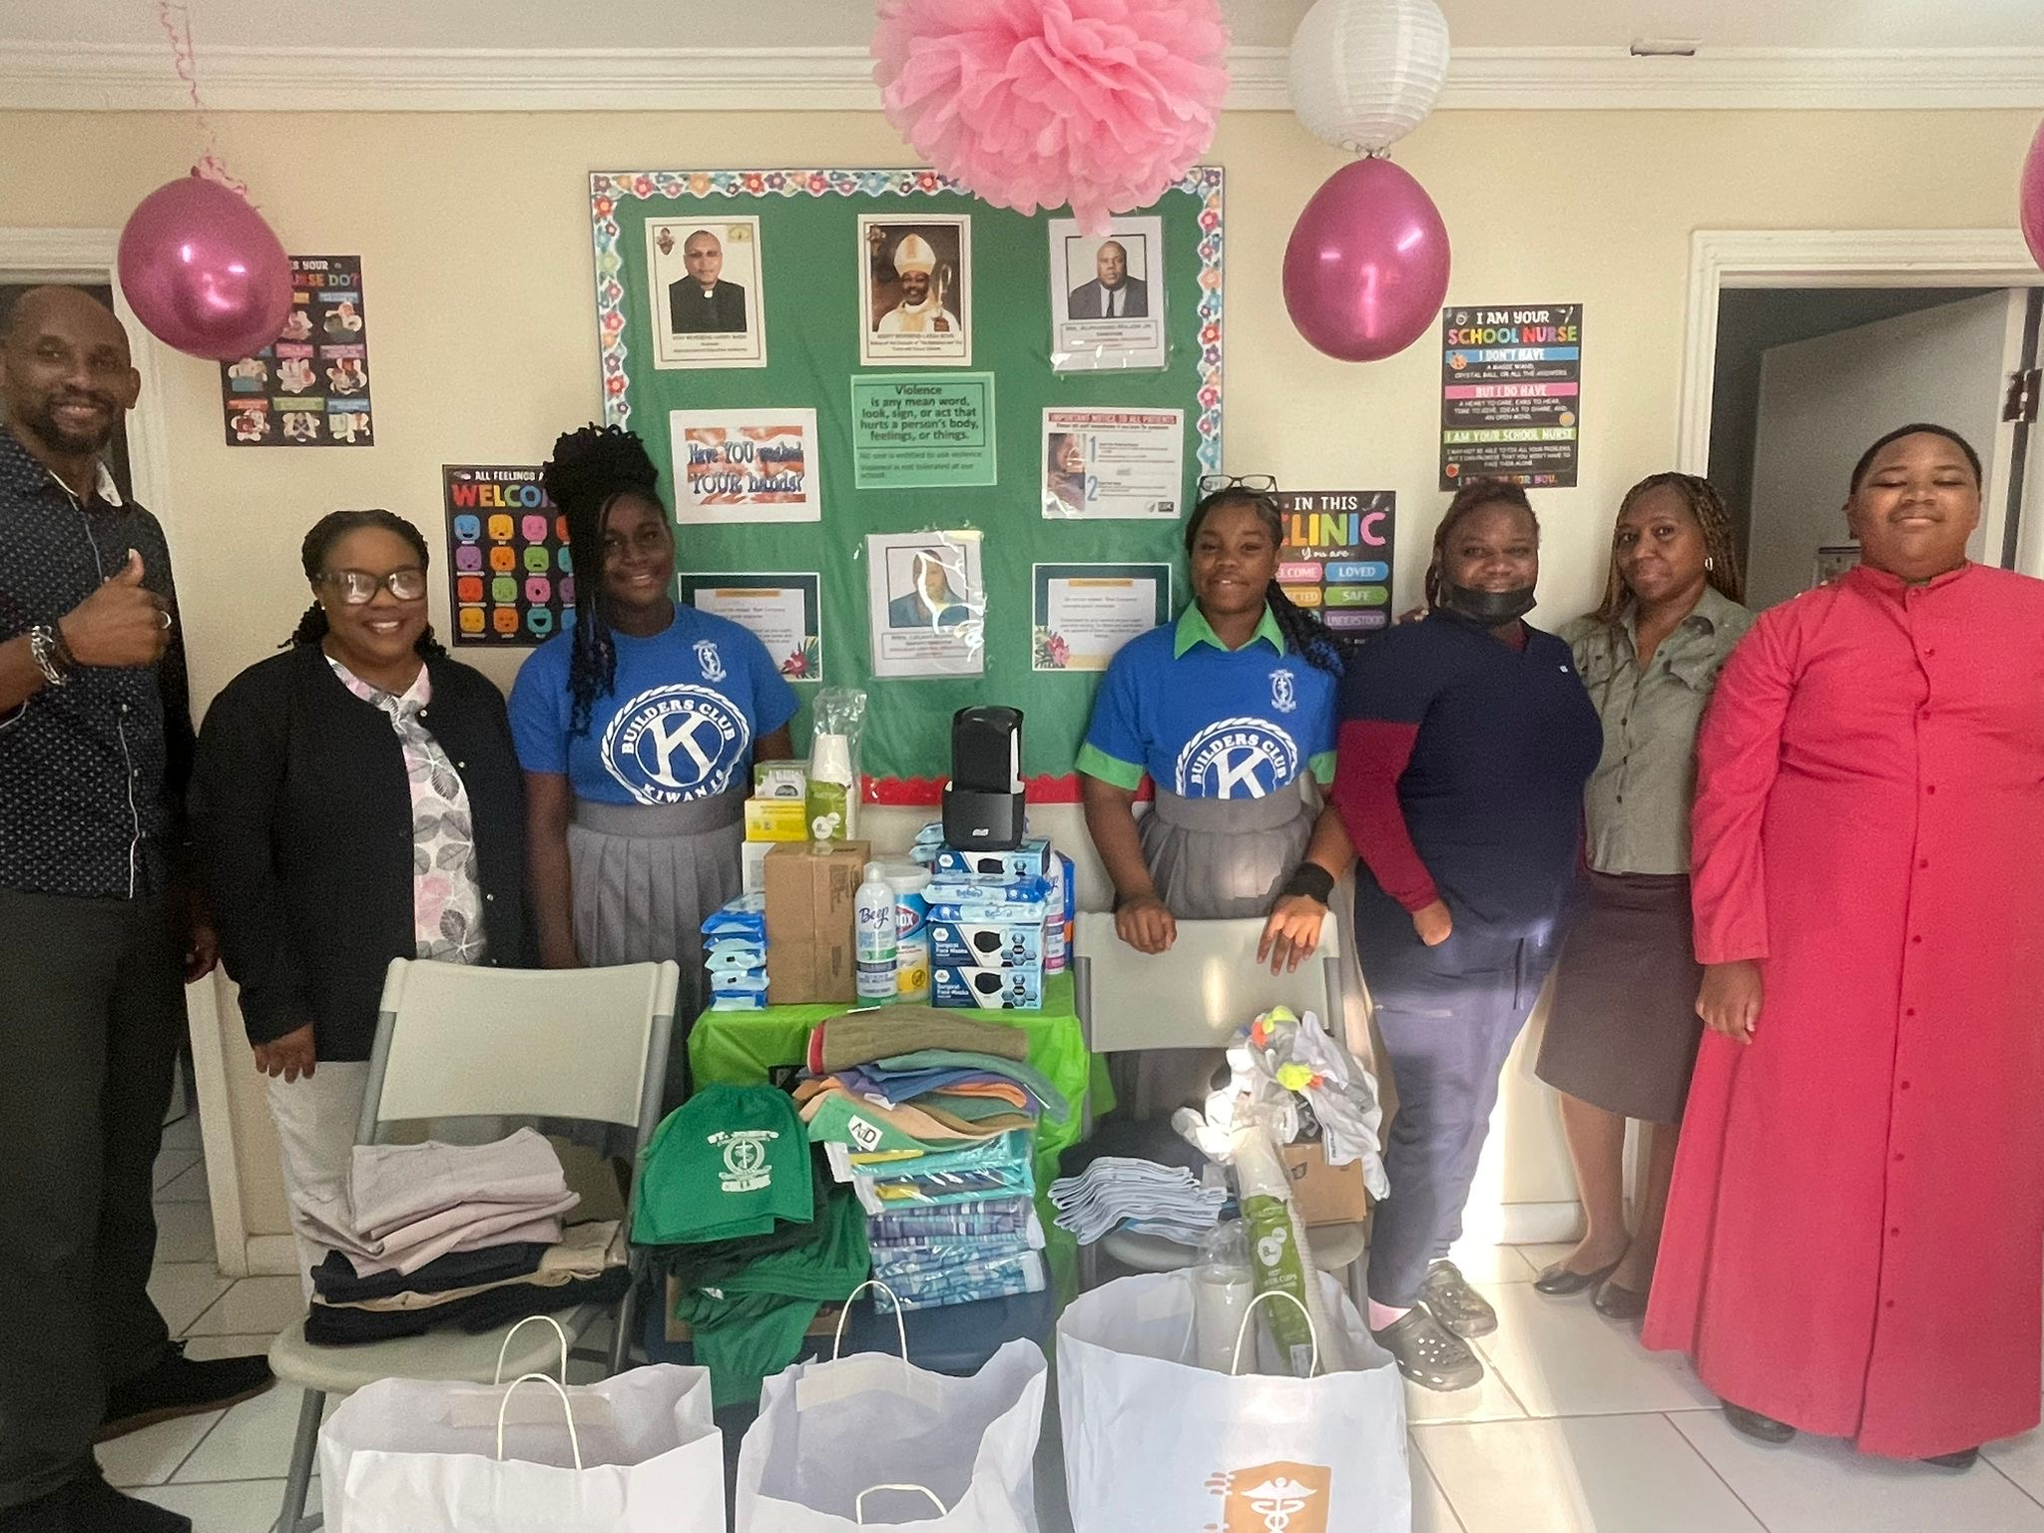

Items Donated Included:
- NEW UNDERWEAR
- LIGHTLY USED UNIFORMS
- HAND SANITIZERS
- DISPOSABLE FACE MASKS
- DISINFECTANT WIPES
- WASH CLOTHS
- DISPOSABLE PAPER CUPS
- THANK YOU BAGS
- TEA BAGS
- SUGAR PACKETS
- SINGLE BED SHEETS
- 5 CASES OF WATER

